# 2.Git-HOL

1. Create a .log file and log folder  
 Command: $ echo "Some log content" > log/sample.txt

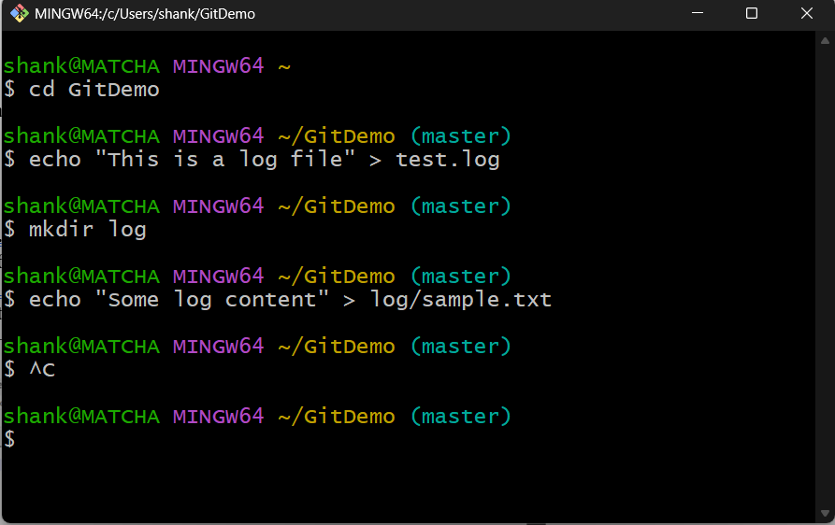

# Step 2: Create and Edit .gitignore File

1. Create a .gitignore file if not already present
2. Open the file in Notepad and add gitignore rules

Command: notepad++ .gitignore

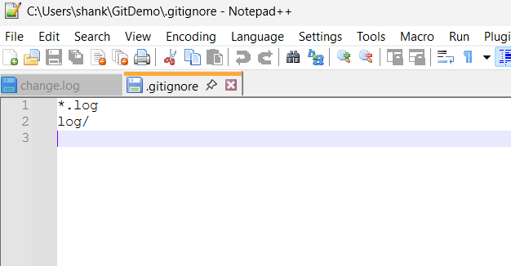

# Step 3: Verify Git Status

1. Check with files Git is tracking

Command: git status

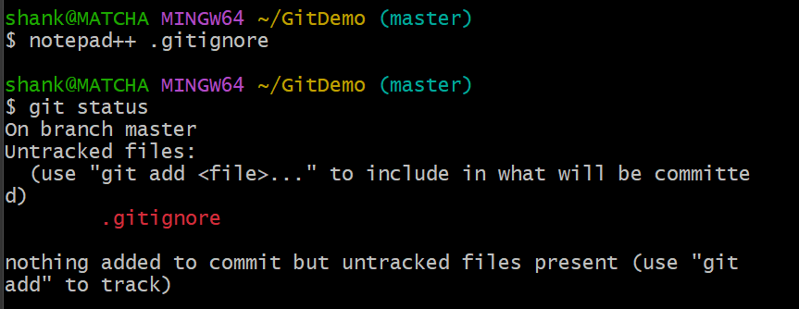

# Step 4: Commit the .gitignore File

Command: git push origin master

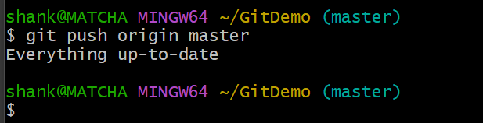

See, Clearly they are not visible here  
